**To Create EC2**

**Step-1**

Login to AWS cloud

<https://www.awsacademy.com/LMS_Login>

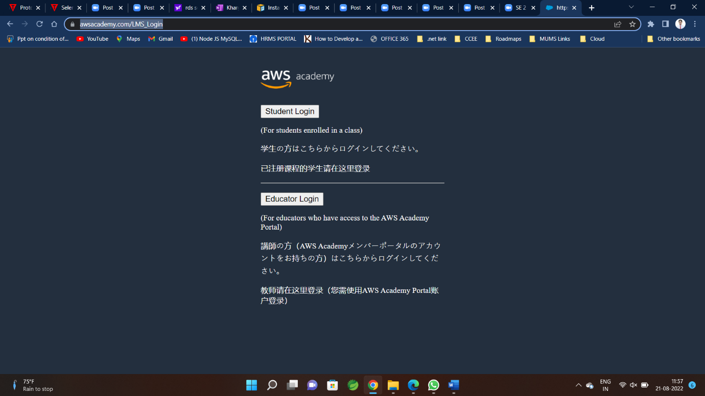

**Step-2**

After Login Go to Course 🡪 click on Module🡪Learner Lab

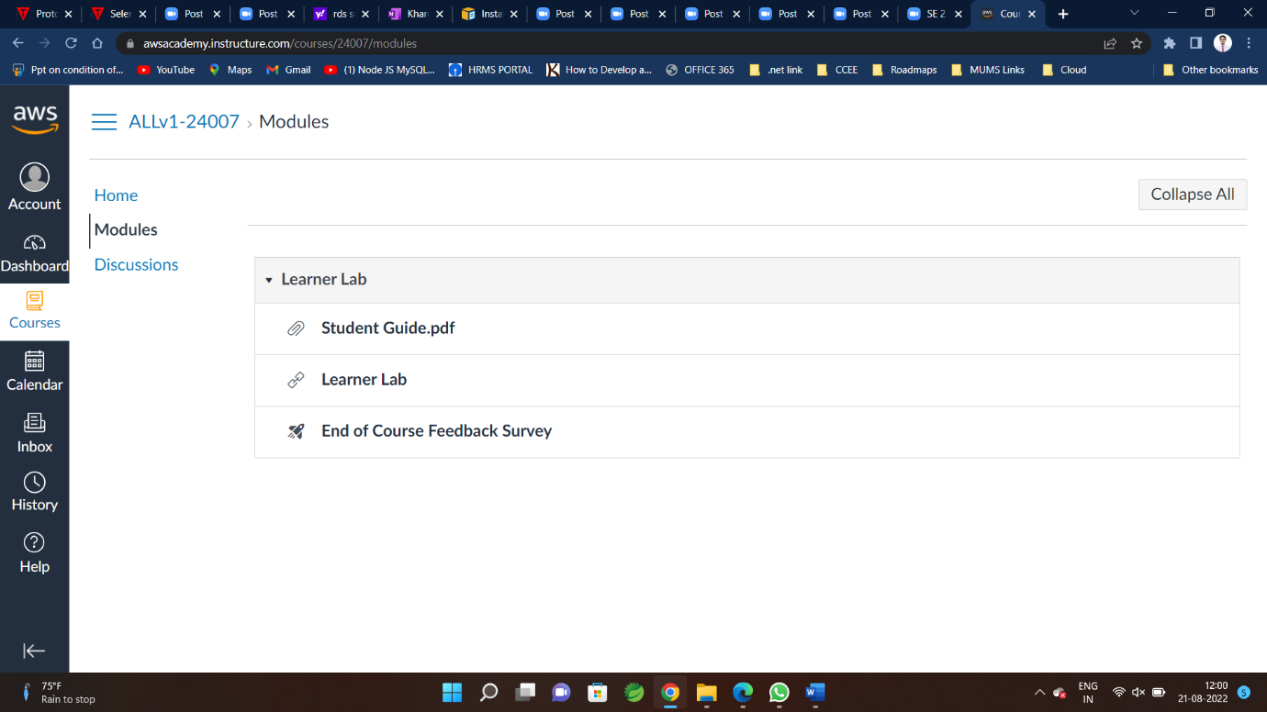

**Step-3 Lab Starting GUI is shown as below**

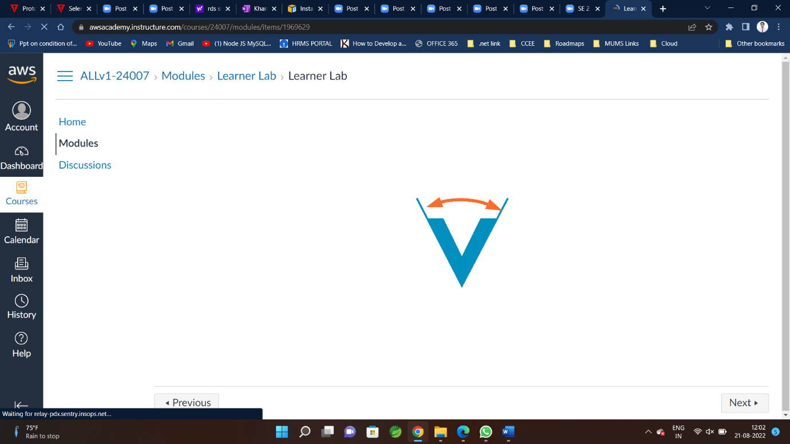

**Step-4**

**Click on AWS**

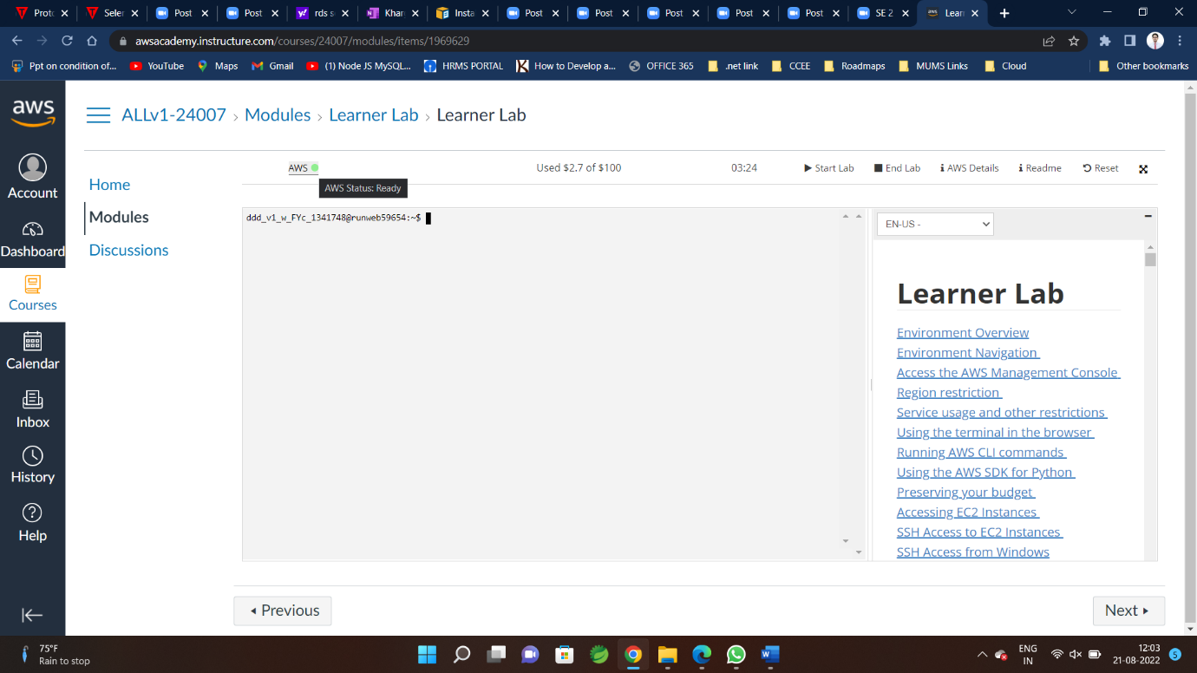

**Step-5 To create EC2**

**Go to Services🡪 Compute🡪EC2**

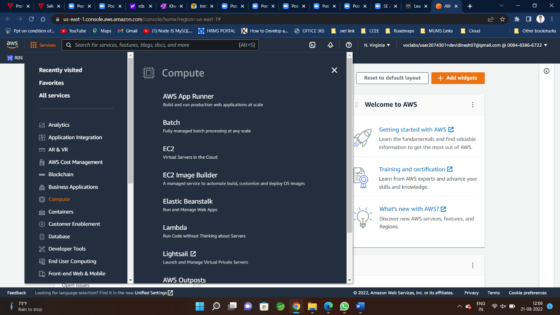

**Or if you now the service Name Directly Type in search Bar –Name of Service (ex.EC2)**

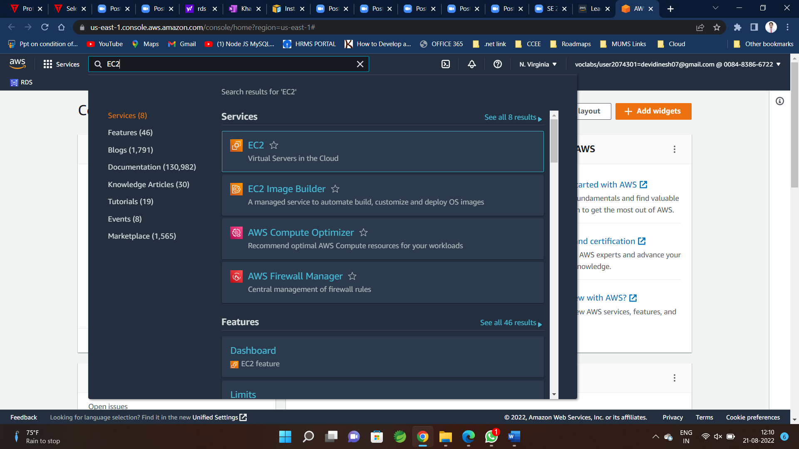

**Step-6**

**Click on EC2🡪Launch Instance**

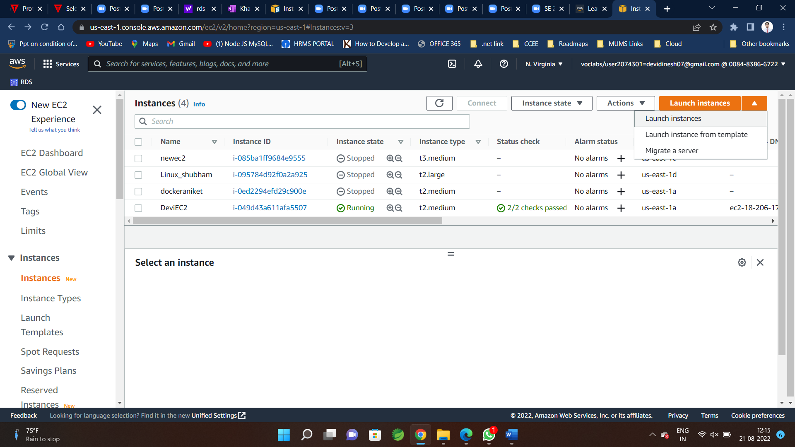

**Or Directly click here**

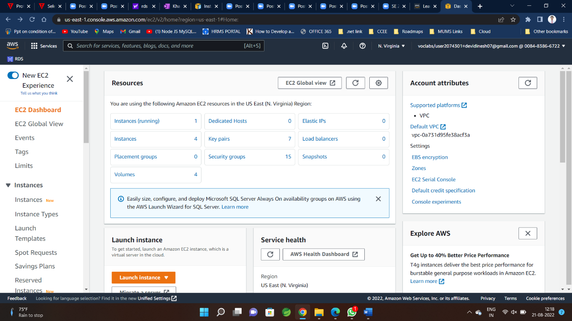

**Step-7**

**Select Proper name for instance**

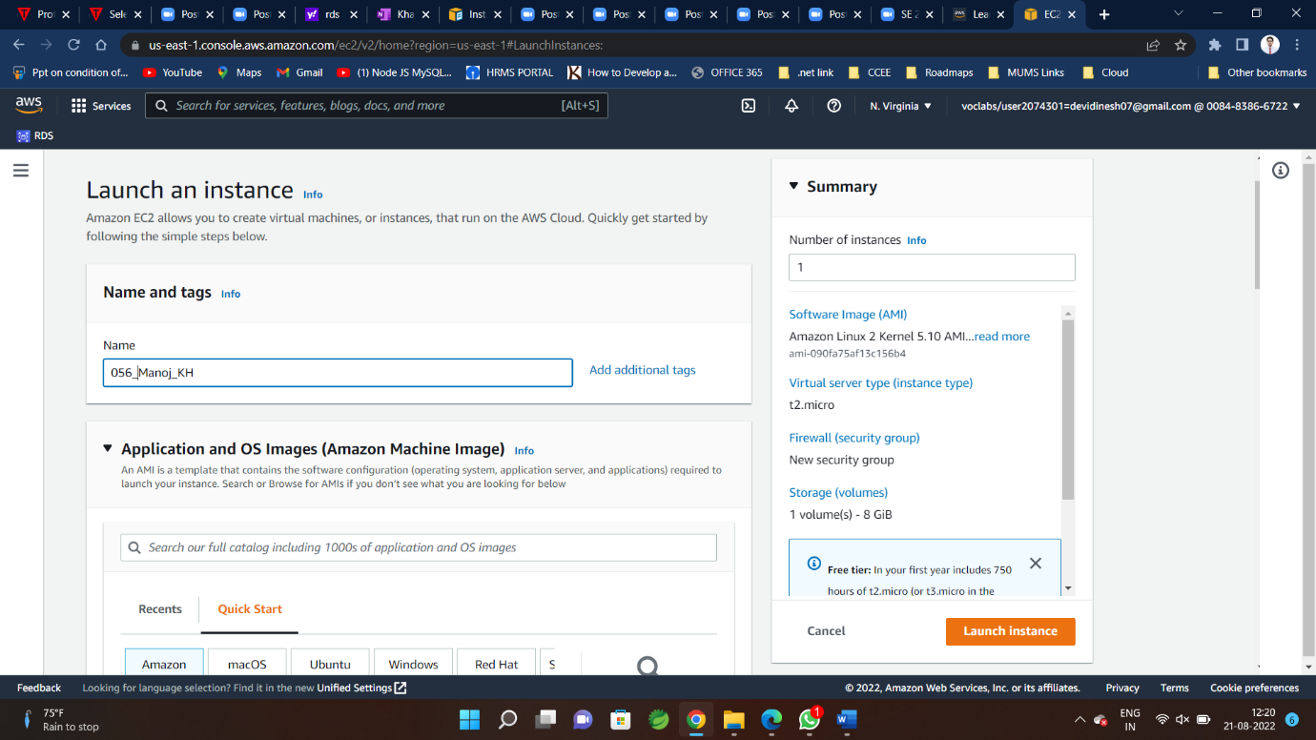

**Step-8**

Select OS as per Requirements(windows/Amazon Linux/macOS ) etc

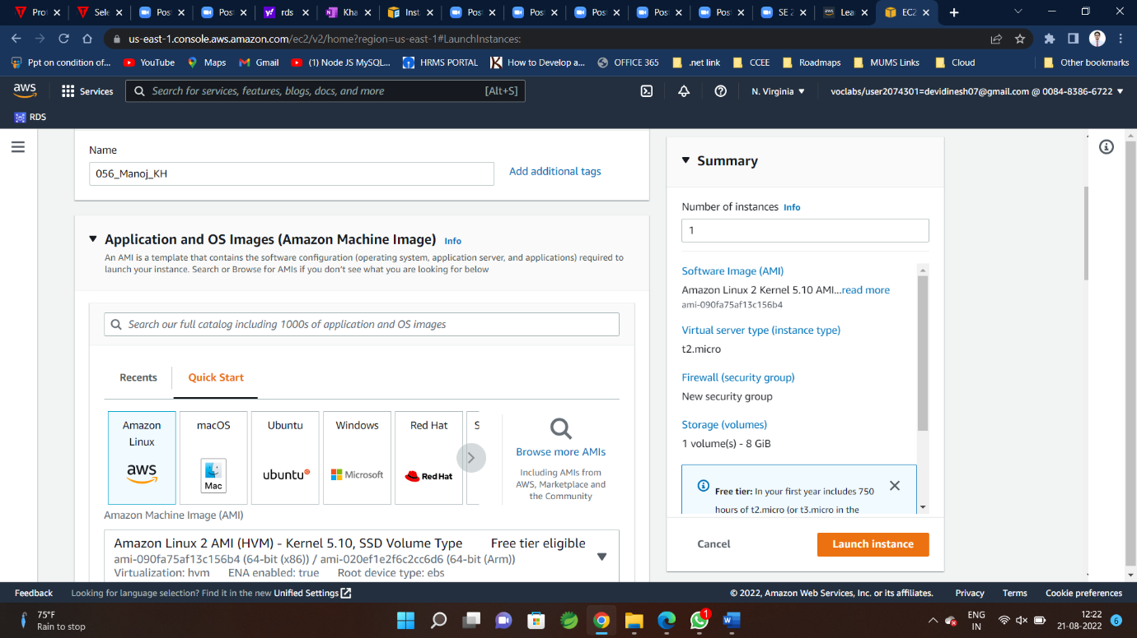

**Step-9**

**Select proper instance Type as per Requirement**

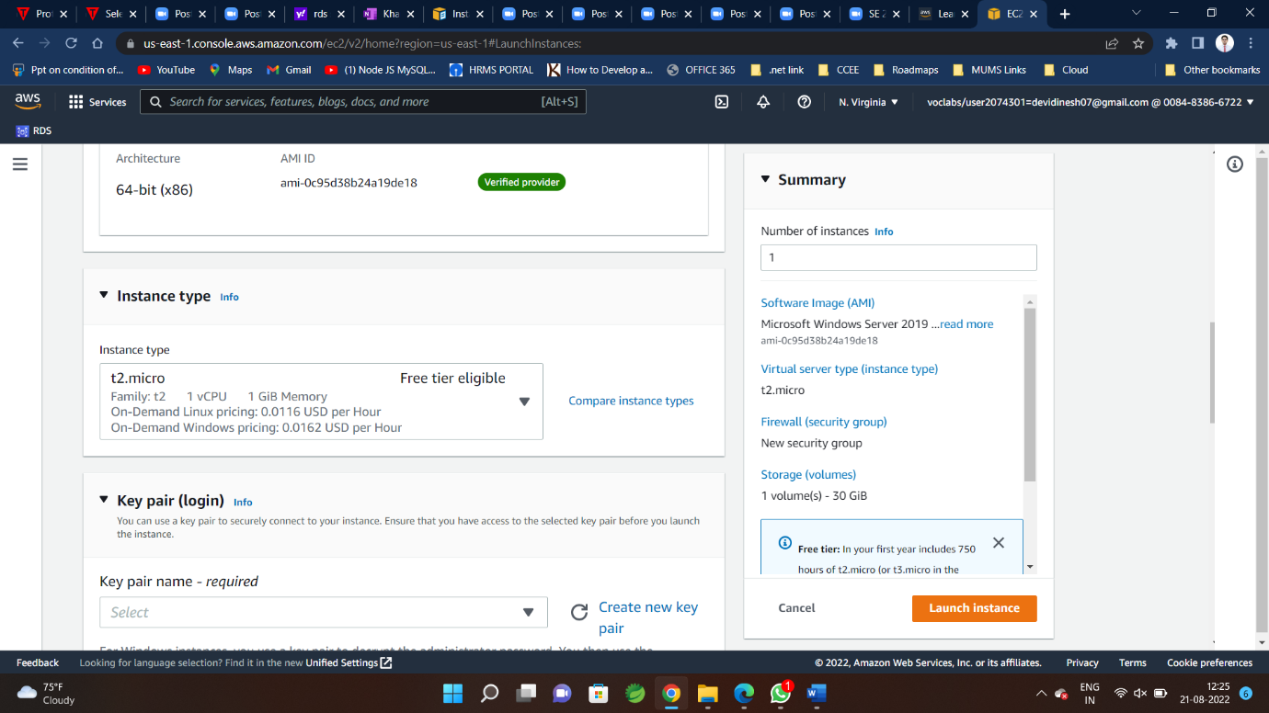

**Step-10**

**If instance Creating for first time 🡪Create new key Pair**



**Step 10.1**

**Give proper name for key value pair**

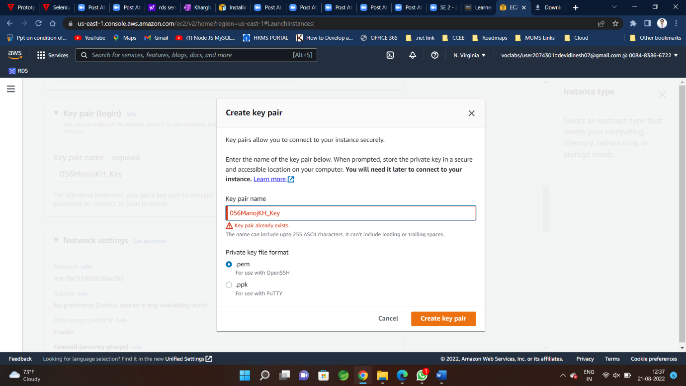

**Step 10.2 keep downloaded .pem file at safe place for further use and security purpose**

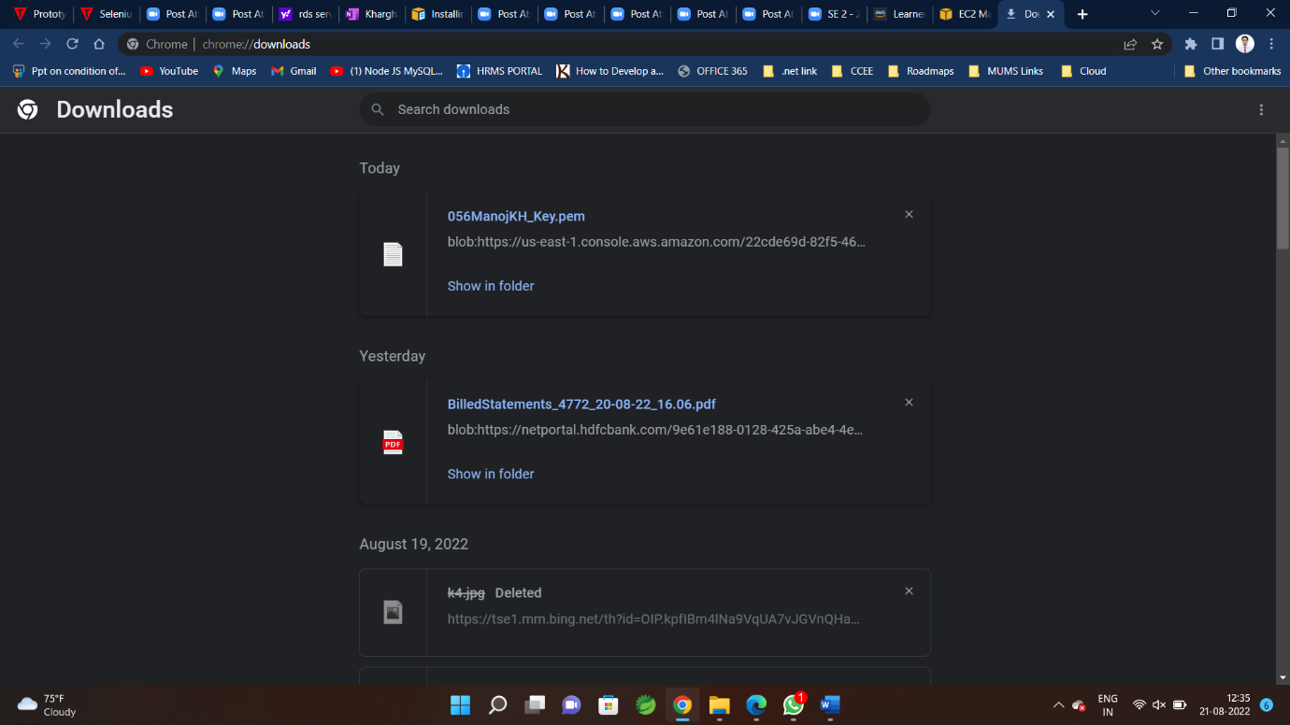

**Or use from Drop Down(if already created)**

**Reaccommodate to use existing key value pair for all instances**

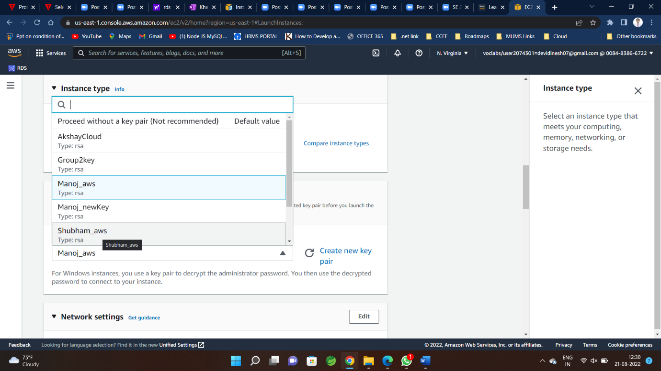

**Step-11**

**Initially firewall(Security groups)🡪create security groups**

**And keep allow RDP traffic From Anywhere**

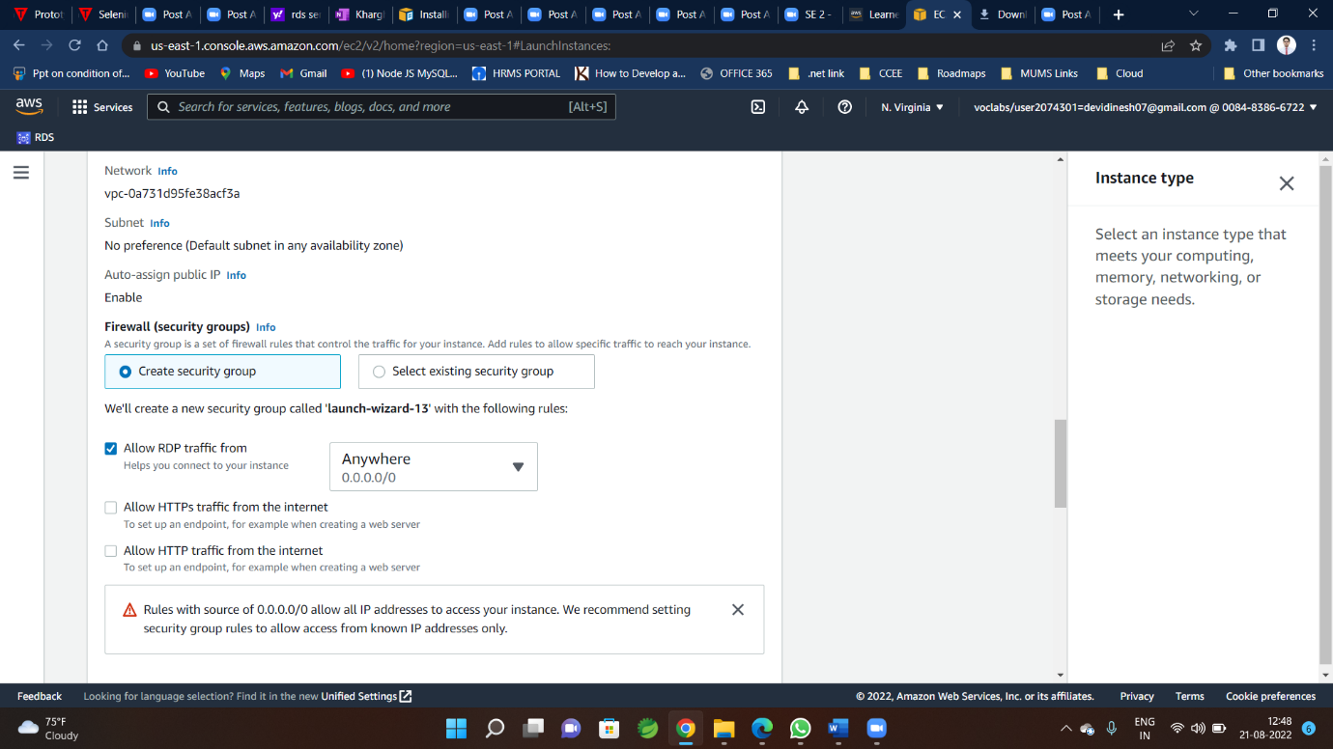

**Step-12**

**Configure Storage 🡪 select as per requirement**

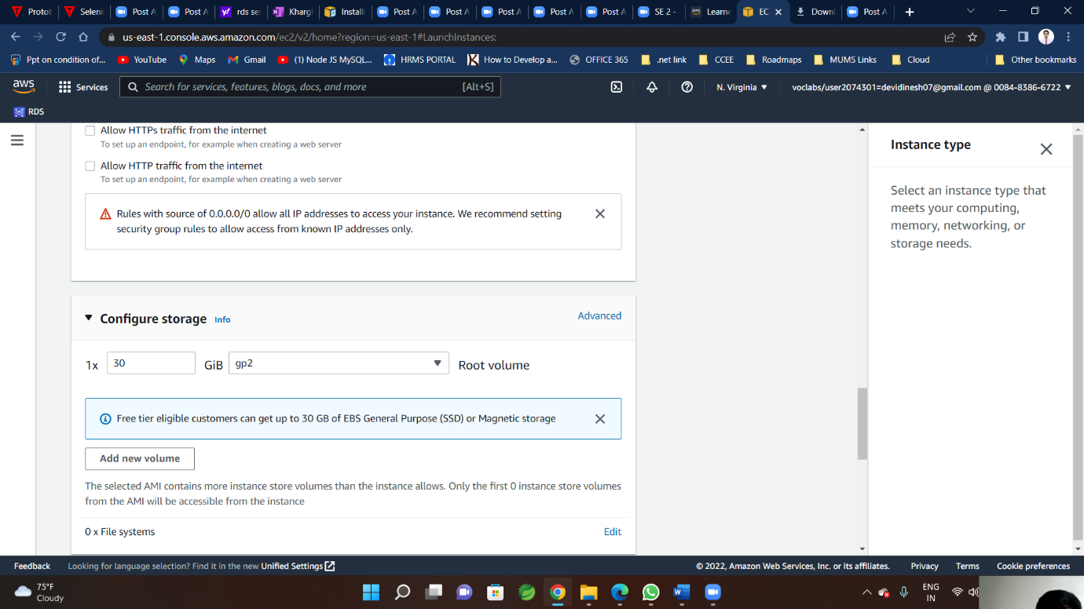

**Step-13**

**Click on Launch Instance**

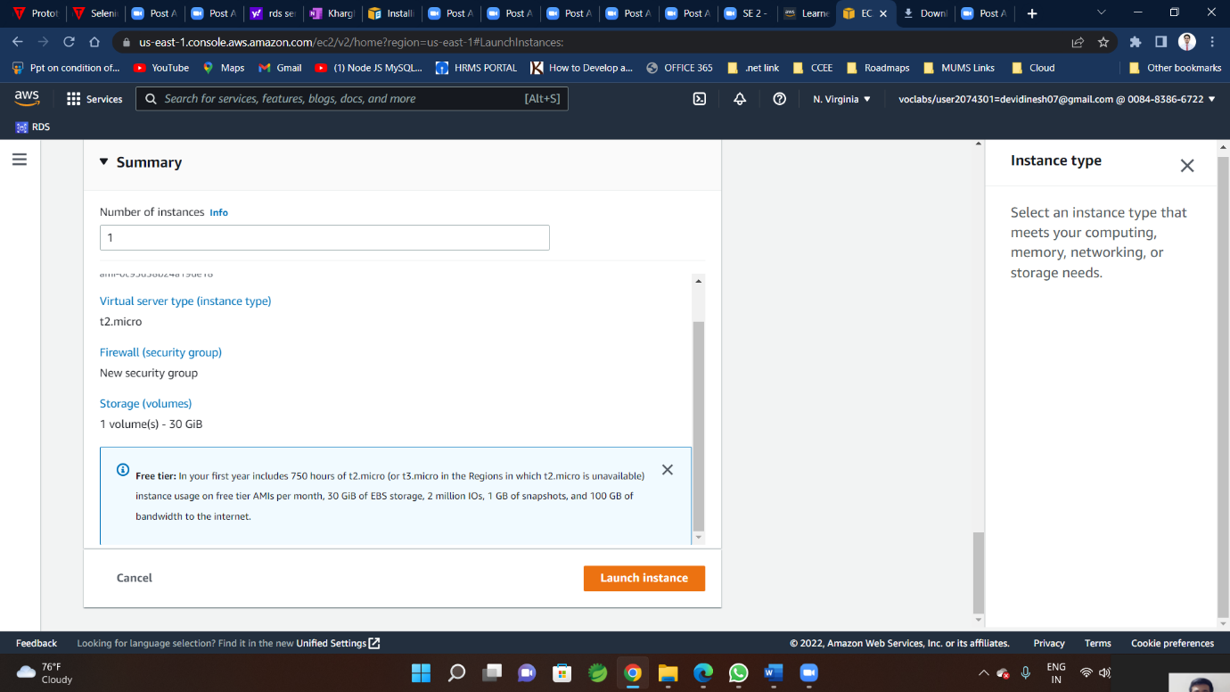

**Step-14**

**Success message for instance created**

